Raspberry PI setup

Install

Database: <http://www.raspberry-projects.com/pi/software_utilities/web-servers/mysql>

sudo apt-get install mysql-server

sudo apt-get install php5-mysql

debug:

nodejs RemoteDebug.js server.js

auto start:

Log into to pi as root in putty

Copy ”nodecurtain.service” to /etc/system/system

Enable and start:

$ sudo systemctl enable nodecurtain.service

$ sudo systemctl restart nodecurtain.service

$ ps aux

Tools

1. FTDI Chip USB to RS485 converter cable
2. Free Virtual Serial Ports software to map Somfy software com port to diagnostic output
3. Tera Term to log binary data
4. Binary editor (in Visual Studio)
5. Somfy STN String Caclator
6. Somfy ILT2 and ST30 RS485 motor configuration software
7. SOMFY RS485 Protocol User’s Guide document version 0.2 2009-10-26

Process:

Map virtual com pots:

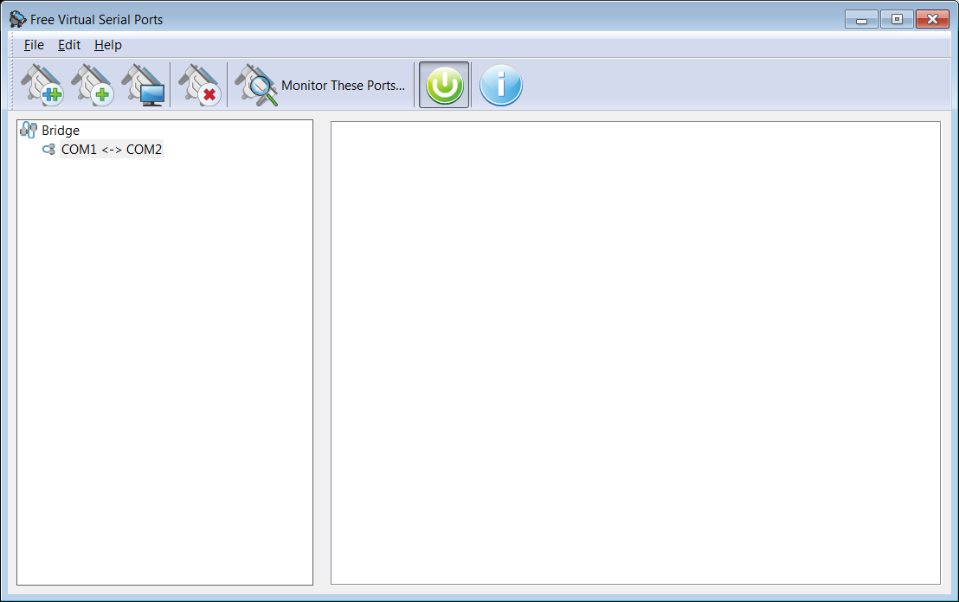

SOMFY RS485 Protocol User’s Guide

Every bit of the transmission except the checksum is inverted before transmission

Checksum is the sum of the inverted data truncated to 2 bytes.